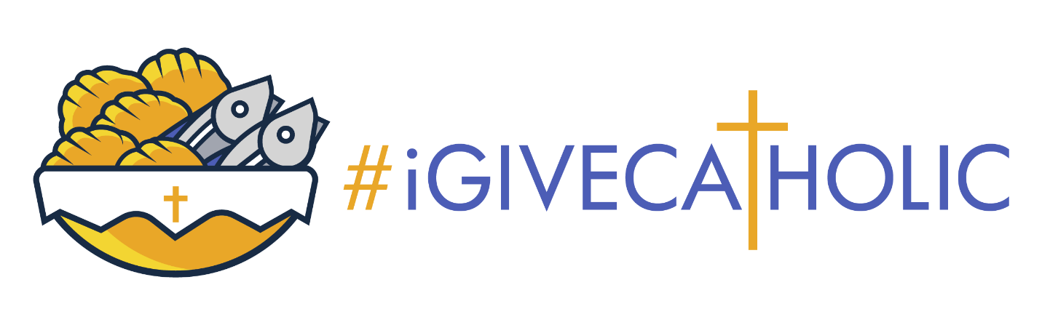

The #iGiveCatholic Giving Day campaign will take place on Tuesday, November 28th from 12:00 AM – 11:59 PM. This is a special opportunity to celebrate our faith and to show our gratitude for the many blessings we have received.
Today we enter the Advanced Giving Phase of the campaign. It runs through November 27th. We are hoping to get off to a fast start in our effort to raise $XX,XXX for (enter project description here).
Here’s how you can help:
- Make an offline donation of cash or a check (payable to) and send to (mailing address)
- Make an online donation at (insert your unique profile page URL link here) on November 28th
- Help us spread the word! Text a friend. Forward this email. Tell someone in person. Like our posts on social media and share them with others.
Be sure to follow along with our progress on Tuesday, November 28th as the leaderboard climbs. Live updates can be found on that date at https://stl.igivecatholic.org/.
Thank you in advance. We appreciate your faith in the work we do each and every day. Your prayers and support truly make a difference!

(Insert a photo or two of your school or ministry at work or use our #iGC one)

